United in Review: Manchester United 2017 – 2018 Premier League Recap

Season Overview

Transfers

|  |  |  |  |
| --- | --- | --- | --- |
| Players In | | | |
| Player | Reported Cost | Club from | Date Assigned |
| Romelu Lukaku | 84.7 million | Everton | July 10, 2017 |
| Nemanja Matic | 44.7 million | Chelsea | July 31, 2017 |
| Victor Lindelöf | 35.0 million | Benfica (POR) | July 1, 2017 |
| Alexis Sanchez | Swap Deal | Arsenal | January 22, 2018 |

Courtesy: Transfermarkt https://www.transfermarkt.com/manchester-united/transfers/verein/985/saison_id/2017

|  |  |  |  |
| --- | --- | --- | --- |
| Players Out | | | |
| Player | Reported Cost | Club to | Date Assigned |
| Adnan Januzaj | 8.5 million | Real Sociedad (ESP) | July 12, 2017 |
| Zlatan Ibrahimović | Free | Released | March 22, 2018 |
| Wayne Rooney | Free | Everton | July 9, 2017 |
| Henrikh Mkhitaryan | Swap Deal | Arsenal | January 22, 2018 |
| Guillermo Varela | Undisclosed | Penarol (ARG) | 12 August,2017 |

Courtesy: Transfermarkt https://www.transfermarkt.com/manchester-united/transfers/verein/985/saison_id/2017

Table Finish

|  |  |  |  |  |  |  |  |  |  |
| --- | --- | --- | --- | --- | --- | --- | --- | --- | --- |
|  | Wins | Draws | Losses | Clean Sheets | Goals For | Goals Against | Goal Difference | Points | Position |
| Home | 15 | 2 | 2 | 12 | 38 | 9 | + 29 | 47 | 2nd |
| Away | 10 | 4 | 5 | 7 | 30 | 19 | + 11 | 34 |
| **Total** | **25** | **6** | **7** | **19** | **68** | **28** | **+ 40** | **81** |

Courtesy: Soccerstats.com

+ United finished 2nd with 81 points, an impressive effort considering it is the most points tallied since Sir Alex Ferguson’s final season as United manager in 2013.

+ Old Trafford was a fortress this season, with United only allowing 9 goals and keeping 12 clean sheets at home, losing only twice.

- Struggled defensively in away fixtures, conceding more than double the amount suffered at home.

Player Statistics

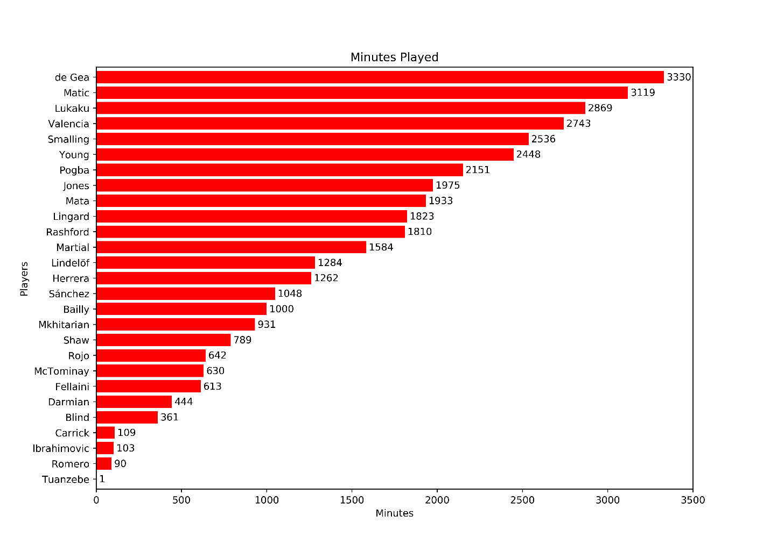Minutes and Appearances

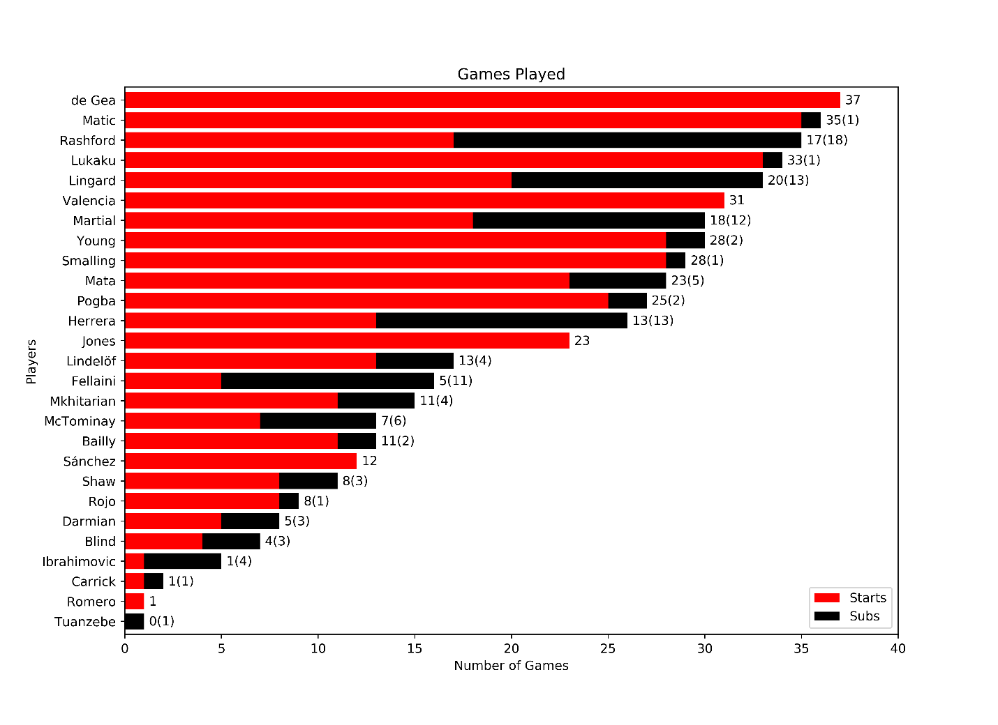

Nemanja Matic has been a crucial player for United in his first season at the club. Featuring in 36 out of 38 league matches and starting in all but one of them, he has been the go-to replacement in the DM role held by Michael Carrick in previous seasons. Carrick only featured in 2 league games in his last season, the United veteran would go on to join Jose Mourinho’s coaching staff after his retirement.

David de Gea further cemented himself as United’s Number 1 in the league, missing out on only one game this season.

Zlatan Ibrahimović has had a disappointing run this time around, playing 5 games with 1 start. With the lowest minutes played of all United attacking players, Ibrahimović season was severely hindered by injury. An ACL injury at the tail end of 16/17 season along with a knee injury in December ultimately lead to his mutual termination in March. The Sweden later signed for LA Galaxy in the MLS.

Most Featured Premier League XI

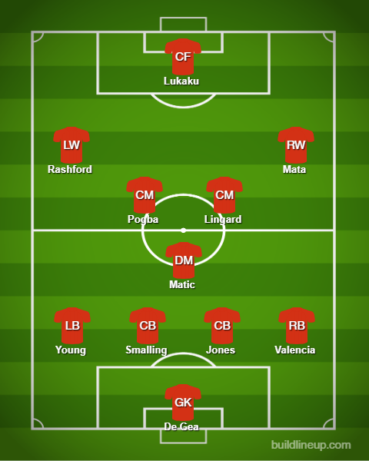

Goals and Assists

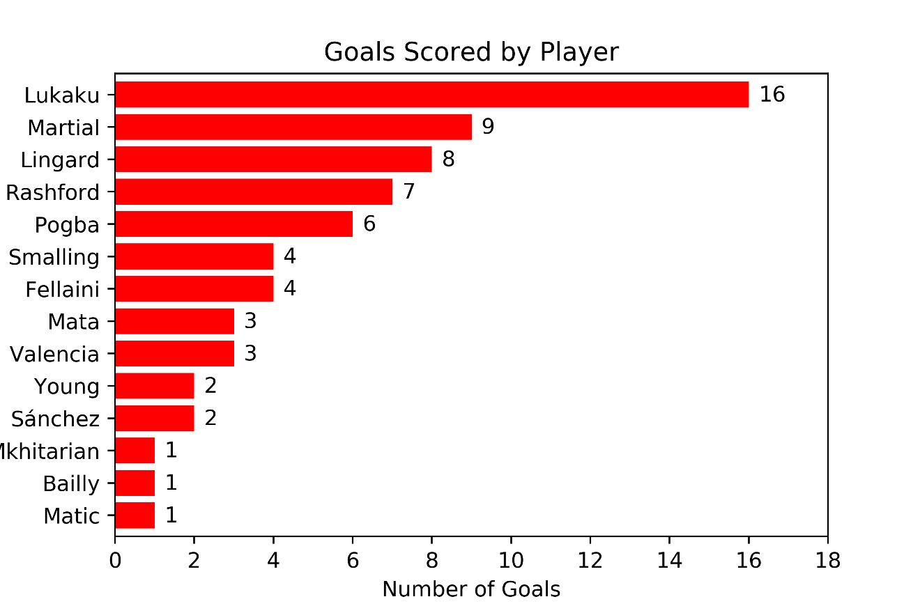

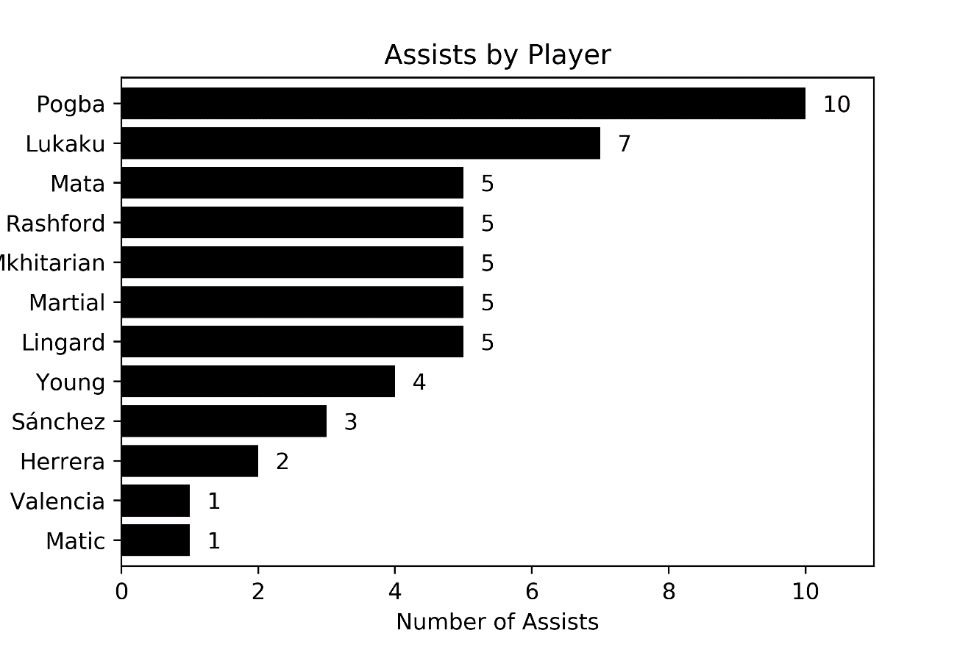

Romelu Lukaku has been a key player in United’s attack, netting a club high of 16 goals and completing 7 assists. Although Lukaku was not in contention for the Golden Boot, United’s attack did not solely rely on the striker for goals. Goals also came from the wings, with Anthony Martial, Marcus Rashford, Jesse Lingard, Juan Mata, and Alexis Sanchez scoring a combined 27 goals.

Paul Pogba’s league performance was a great improvement compared to last season. Previously scoring 5 and assisting 6 goals in 30 games, Pogba scored 6 goals and topped the club with 10 assists in 27 matches this season. This may have been a result of having Nemanja Matic as part of the midfield three. Having an experienced defensive midfielder to cover the defence allows Pogba to freely assume a playmaker position from the midfield in the attack.

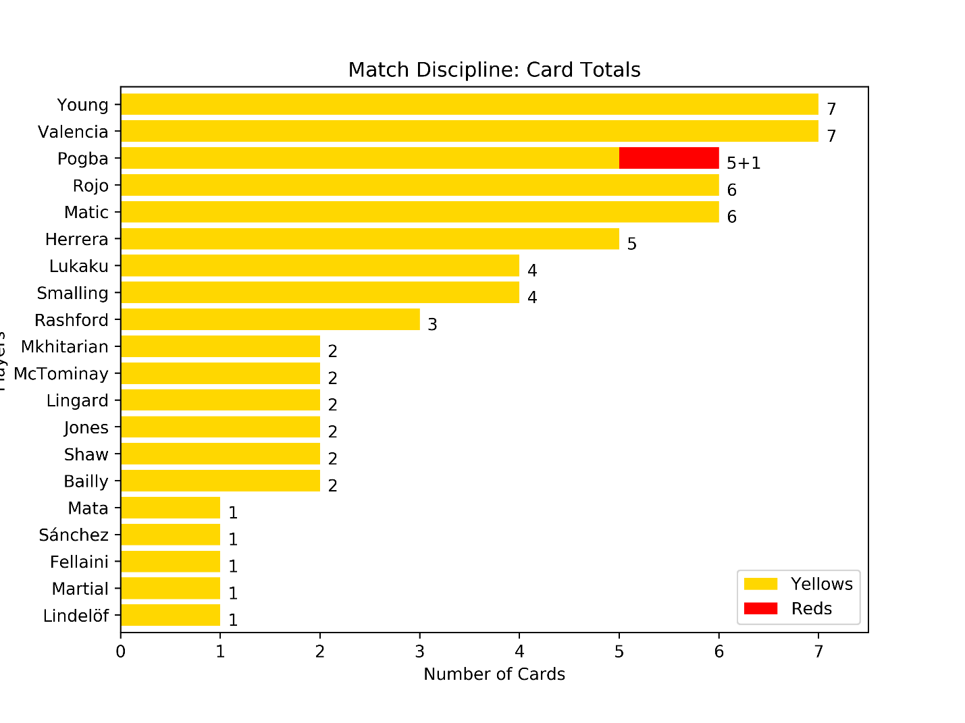Discipline

United met with a fair share of disciplinary action from Premier League officials. The club have accrued the 5th highest yellow card tally in the league with 64 cards. On the other hand, they tie for the Leagues lowest number of reds with the one shown to Pogba in the match against Arsenal at the Emirates.

Both of United’s first choice full-backs, Ashley Young and Antonio Valencia, had the most yellows in the club. Given the additional attacking duties expected from these defensive players in Jose Mourinho’s system, tactical fouls are often necessary to stop counterattacking movements from opposing wingers when caught higher up the pitch.

Marcos Rojo finished the season with the highest card per game ratio of 66.7%, collecting the 3rd highest card tally of 6 yellows in only 9 appearances for United in the league. As a centre-back, this is a drawback as carded defenders are forced to tone down their physical play in fear of a sending off. It also encourages the opposition to target these defenders, expecting less resistance or to draw fouls.